UNIVERSITI TEKNOLOGI MARA

STRATEGIES OPTIMIZATION FOR RUGBY TEAM USING GENETIC ALGORITHM (GA)

AHMAD HARRIS HAFIZIN BIN HARDE

BACHELOR OF COMPUTER SCIENCE (Hons.)

JULY 2025
Universiti Teknologi MARA

Strategies Optimization for Rugby Team using Genetic Algorithm (GA)

Ahmad Harris Hafizin Bin Harde

Thesis submitted in fulfilment of the requirement for Bachelor of Computer Science (Hons.) College of Computing, Informatic and Mathematic

July 2025

SUPERVISOR APPROVAL

STRATEGIES OPTIMIZATION FOR RUGBY TEAM USING GENETIC
ALGORITHM (GA)

By

AHMAD HARRIS HAFIZIN BIN HARDE
2024977473

This thesis was prepared under the supervision of the project supervisor, Ts. Dr. Shaiful Bakhtiar Bin Rodzman. It was submitted to the College of Computing, Informatic and Mathematic and was accepted in partial fulfilment of the requirements for the degree of Bachelor of Computer Science (Hons.).

Approved by

……………………………..
Ts. Dr. Shaiful Bakhtiar Bin Rodzman
Project Supervisor

JULY 22, 2025

STUDENT DECLARATION

I certify that this thesis and the project to which it refers is the product of my own work and that any idea or quotation from the work of other people, published or otherwise are fully acknowledged in accordance with the standard referring practices of the discipline.

……………………………..
AHMAD HARRIS HAFIZIN BIN HARDE
2024977473

JULY 22, 2025

ACKNOWLEDGEMENT

Alhamdulillah, praises and thanks to Allah for His blessings and guidance, I was able to complete this research successfully within the given timeframe.

Firstly, I would like to express my sincere gratitude to my supervisor, Ts. Dr. Shaiful Bakhtiar Bin Rodzman, for his continuous support, guidance, and valuable advice throughout the development of this project. His encouragement and constructive feedback have been instrumental in shaping this research.

Special thanks to my beloved parents for their endless prayers, love, and moral support throughout my academic journey. My parents will be always my number one supporter any time. Their advice helping me a lot during the given timeframe.

I would also like to extend my appreciation to all my friends who have helped me directly or indirectly, especially during difficult times.

Last but not least, this project has been a great learning experience for me, and I am truly grateful for the opportunity to complete it with the help of those around me.

TABLE OF CONTENTS

CONTENT PAGE

SUPERVISOR APPROVAL iii
STUDENT DECLARATION iv
ACKNOWLEDGEMENT v
TABLE OF CONTENTS vi
LIST OF TABLES x
LIST OF ABBREVIATIONS xi

CHAPTER 1 1
INTRODUCTION 1

1.1 Background of Study 1
1.2 Problem Statement 4
1.3 Objective 6
1.4 Project Scope 6
1.5 Project Significance 7
1.6 Overview of Research Outline 7
1.7 Conclusion 9

CHAPTER 2 11
LITERATURE REVIEW 11

2.1 Introduction 11
2.2 Optimization System 11
2.2.1 Phase of optimization 12
2.3 Strategies optimization 13
2.4 Genetic algorithm 19
2.4.1 How genetic algorithm works 20
2.4.2 Advantages of using genetic algorithm 23
2.5 Implementation of Genetic Algorithm in Various Domains 25
2.5.1 Gradient genetic algorithm for drug molecular design 29
2.5.2 Improved genetic algorithm based on greedy and simulated annealing ideas for vascular robot ordering strategy 30
2.5.3 Two-stage genetic algorithm for optimization logistics network for groupage delivery 30
2.5.4 Development of adaptive lecture scheduling system using genetic algorithm 30
2.5.5 Application of a genetic algorithm for proactive resilient scheduling in construction projects 31
2.5.6 Optimization of genetic algorithm in courses scheduling 31
2.5.7 A genetic algorithm tool for conceptual structural design with cost and embodied carbon optimization 32
2.5.8 Two genetic algorithms for final exam scheduling 32
2.5.9 Optimizing service scheduling by genetic algorithm support decision-making in smart tourism destinations 32
2.5.10Genetic algorithm based on natural selection theory for optimization problems 33
2.6 Similar works 33
2.7 Implication of literature review 38
2.8 Conclusion 38

CHAPTER 3 40
RESEARCH METHODOLOGY 40

3.1 Overview of research methodology 40
3.1.1 Research framework 40
3.2 Preliminary phase 43
3.2.1 Literature study 43
3.2.2 Interview session 43
3.2.3 Data collection 44
3.2.4 Data pre-processing 45
3.3 Design and development phase 45
3.3.1 System architecture 46
3.3.2 Algorithm flowchart 47
3.3.3 User interface design 48
3.3.4 Pseudocode of genetic algorithm 49
3.3.5 Strategy and attribute mapping 51
3.4 Performance evaluation 55
3.4.1 Fitness function 55
3.5 Project planning 60
3.5.1 Gantt chart 60
3.6 Conclusion 60

REFERENCES 62

LIST OF FIGURES

FIGURE PAGE

Figure 2.1 Classification of key performance indicators in Rugby Sevens 15
Figure 2.2 Key performance indicator definitions 15
Figure 2.3 Example of three mutation operators 23
Figure 3.1 Screenshot of Interview Session……………………………………………………………………….44
Figure 3.2 Statistic of best Rugby Player in 2023/2024 45
Figure 3.3 System Architecture 46
Figure 3.4 Flowchart of Genetic Algorithm 48
Figure 3.5 Example of strategies optimization prototype user interface 49
Figure 3.6 Example of Gene for Player 1 of Pick and Go Strategy 54
Figure 3.7 Example of Chromosomes for Strategy Pick and Go and 10 Players 54
Figure 3.8 Example of Convergence graph 59
Figure 3.9 Project's Gantt chart 60

LIST OF TABLES

TABLE PAGE

Table 1.1 Overview of research framework 8
Table 2.1 Type of Optimization from different study 12
Table 2.2 Key performance indicators (PIs) related to Winning in Rugby Union 16
Table 2.3 Key performance indicators (PIs) related to Winning in Rugby Sevens 17
Table 2.4 Key performance with benchmark 18
Table 2.5 Implementation of GA in various problem 25
Table 2.6 Similar Application 33
Table 3.1 Detailed Research Framework 41
Table 3.2 Pseudocode of Genetic Algorithm 49
Table 3.3 Basic Play mapping 52
Table 3.4 Tactical Play Mapping 52
Table 3.5 Contingency Play Mapping 54
Table 3.6 Example of 5 population 56
Table 3.7 Fitness Function Calculation 57
Table 3.8 Example calculation for accuracy 60

LIST OF ABBREVIATIONS

GA Genetic Algorithm
FYP Final Year Project
RU Rugby Union
RS Rugby Sevens
UI User Interface
RR Risk Ratio
CI Confidence Interval
KPI Key Performance Indicator
NSGA-II Non-dominated Sorting Algorithm II
DLP Discrete Langevin Proposal
AI Artificial Intelligence
RAD Rapid Application Development
VRP Vehicle Routing Problem
ABLVR Aortic Balloon Lithotripsy Vascular Robot
UTP Universiti Teknologi Petronas
Uitm Universiti Teknologi Mara

CHAPTER 1

INTRODUCTION

This chapter provides the background and rationale for the study. It also gives details of the significance of strategies optimization for rugby team using genetic algorithm (GA), the issues and problems that led to this research.

  - Background of Study

Rugby is a team sport played by two opposing sides and is conducted in a group setting. The game has several variations 7’s, 10’s, and 15’s based on the number of players on the field during a match. Players must carry the ball into the opponent’s goal area, known as the “in-goal” or “try line,” to score points. The team with the most points at the end of the match is declared the winner. According to Riaz (2023), rugby ranked fourth among the top ten most popular sports in Malaysia in 2023. As of that year, there were more than 300 rugby clubs and over 600 schools actively involved in the sport nationwide. This reflects the significant growth and rising popularity of rugby within Malaysian society. Furthermore, Malaysia’s national rugby team was ranked 51st in the world, based on the World Rugby Rankings(Women’s and Men’s Rankings | World Rugby, n.d.). Like all competitive sports, rugby requires well-defined strategies to outperform strong opponents. The game includes a variety of tactical approaches, such as attacking strategies like “The Switch,” “Miss Pass,” and “Dummy Switch Screen to 11,” as well as defensive strategies like “Shooter Defence,” “The Drift Defence,” and the “Scrum Half Defensive Role” (Rugby Slate – Rugby Attacking Tactics and Strategies With GIF Examples, n.d.). Therefore, the application of effective strategies can significantly influence match outcomes and overall team performance.

One of the current challenges in rugby strategy planning is the lack of clear methods for coaches to evaluate and improve players’ decision-making. Many coaches still rely on intuition, and there is limited research on how they develop effective strategies both on and off the field (Morgan et al., 2020). This makes it harder to create consistent and optimized game plans. Recent studies also found that coaches often struggle to determine the best timing to apply a specific strategy in order to gain an advantage((PDF) Decision-Making in Rugby and Implications for Coach Education: The Elicited Case of Naturalistic, Differentiated and Disruptive Decision-Making J, n.d.). A wrong move could be easily predicted by the opponent, giving them the upper hand. Additionally, since match situations can change unpredictably, coaches are required to make quick and wise decisions under pressure. This highlights the need for smarter, data-driven approaches in rugby strategy planning.

Optimization refers to the process or methods used to solve quantitative problems across various disciplines by using a unified set of options (Optimization - Theory, Algorithms, Solutions | Britannica, n.d.). In the context of sports like rugby, optimization can be applied in many areas such as line-up selection, performance improvement, and training efficiency. For this research, optimization will be used to identify the most effective strategies or tactics for winning matches. Therefore, a Genetic Algorithm (GA), as a computational optimization technique, will be used to provide a more systematic and intelligent approach to generating strategic decisions. GA is highly effective for strategy optimization because it can search through a large number of possible solutions and evolve to find the most effective combination during the selection, crossover and mutation processes ((7) Genetic Algorithms Explained in 6 Minutes (...and 28 Seconds) - YouTube, n.d.). Compared to traditional methods of strategy planning, GA can handle more complex variables and overcome various possible game scenarios, making it a valuable tool for selecting optimal strategies in rugby.

In optimizing strategy planning for rugby, it is important to consider the real-world indicators that significantly give a big impact gameplay and tactical effectiveness, particularly across different variation of rugby like 7’s and 10’s rugby. The 7’s variation required a faster decision-making, speed, and agility due to its open space and shorter game duration, while 10’s allows for slightly more structured plays with a balance gameplay between forward strength and backline speed. Therefore, incorporating player position-specific strengths such as speed, power, agility, and tactical awareness is essential to assign players to roles that align with the tactical demands of each variation. In addition, understanding the opponent's strategy or playing style can provide an advantage to counterattack by using the opposite strategy or destroying their strategy. In addition, the distance or area of the opponent obtained is also something that needs to be examined when determining a strategy, for example in 10's if we are five meters from the opponent's try line, the appropriate strategy is to use physical forward because playing in close distance. Lastly, weather conditions such as rain, wind, or heat play a big role in determining possibility of implementing a certain strategy, especially in variation like 7’s where quick passes and fast movements are more weather-sensitive. Integrating these four indicators into a Genetic Algorithm allows for a more intelligent and adaptive approach to rugby strategy optimization.

Currently, most rugby coaches rely on manual experience and intuition for strategy planning. To date, there is limited research that explores the use of optimization techniques such as GA in rugby, especially for strategic decision-making. Some existing studies in rugby optimization have focused on specific performance elements, such as optimizing kicking angles and velocities or match prediction using machine learning (Seo et al., 2006; Sreeja et al., 2025). However, these do not address in-game tactical planning or team formation strategy optimization.

A closely related study has applied GA in the context of basketball, showing that GAs can effectively optimize practice regimens and game tactics by simulating biological evolution and iteratively improving strategies based on performance data. This suggests that GA has strong potential for application in rugby, where strategy complexity, decision-making, and teamwork are equally critical. Despite this, the use of GA for strategic planning in rugby remains an underexplored area, highlighting a significant research gap that this study aims to address (DAWEI, 2025).

The purpose of this study is to develop an optimized strategy planning model for rugby teams using GA. This research aims to help local rugby teams improve their strategic decision making by providing a systematic, data-driven approach based on game scenarios. By applying GA, the study seeks to enhance decision making efficiency and enhance overall team performance, supporting the growth of rugby in Malaysia and its improvement in the world rankings.

  - Problem Statement

Despite the proven efficacy of Genetic Algorithms (GAs) in optimizing complex systems, their application in rugby strategy planning remains largely unexplored, particularly within the Malaysian context. A study by (Seo et al., 2006) utilized GAs to optimize the screw kick in rugby, focusing mainly on physical performance aspects rather than strategic planning. Likewise, (DAWEI, 2025) demonstrated the successful application of GAs in basketball for optimizing training and game tactics. However, these studies do not directly address rugby strategy as a whole. While GA has been applied in other sports, the performance indicators used such as shooting angles in basketball or kicking velocity in rugby are not fully transferable to rugby’s complex, dynamic in-game strategies. Rugby involves distinct indicators like player position-specific strengths, opponent tactical, and match-phase conditions, which are rarely considered in existing optimization models. As a result, rugby coaches and analysts lack access to intelligent tools that can evaluate the effectiveness of tactical combinations based on sport-specific factors. This limits their ability to evolve strategies in response to opponents and leading to bad reaction in team performance. To address this gap, this project proposes the development of a GA-based model tailored for rugby strategy optimization using real-world indicators relevant to the sport. By simulating diverse match scenarios and evaluating strategy outcomes, this model aims to enhance coaching decisions and improve match effectiveness.

Rugby coaches are regularly required to make quick strategic decisions during games, often under intense pressure, with no systematic support tools to determine the optimal strategy of action. According to (Morgan et al., 2020) coaches primarily rely on instinct for decision-making and lack defined plans for evaluating strategies. Furthermore, a study evaluating coaches' perceptions of decision-making in rugby union found that developing players' tactical decision-making is one of the most difficult aspects of coaching (Morgan et al., 2020). This a heavy reliance on instinct, along with the lack of real-time support tools, might result in poor decisions during critical game moments. As a result, coaches may use poor strategies or fail to react quickly to changes in gameplay, affecting the team's scoring potential, defensive configuration, and match outcomes. Inconsistency not only degrades team performance, but it can also have an impact on player growth and confidence. Implementing a GA-driven decision support system allows for real-time strategy recommendations based on past data and match scenarios. Such a technology would help coaches make informed decisions quickly, minimizing reliance on instincts and increasing strategic efficacy during matches.

The persistent use of the same methods in rugby matches can create predictability, allowing opponents to predict and neutralize tactics, reducing their efficacy. Middlemas et al. (2018) discovered that overreliance on conventional tactics without modification may slow performance development. Furthermore, because rugby is a dynamic sport, flexible techniques are required to successfully adjust to changing match conditions. When teams continue to apply the same tactical techniques without adjustment, they become simpler to study and beat, especially against well-prepared opponents. This predictability limits a team's capacity to develop and adapt on the field, possibly leading to recurrent losses and a static competitive record. To address this, a GA-based system can aid in the ongoing evolution of strategies by simulating different match conditions and adjusting tactics accordingly. This method encourages strategic diversity and adaptation, which reduces predictability and increases the probability of victory against a wide range of opponents.

  - Objective

The objectives of this project are:

- To identify the application of Genetic Algorithm (GA) in the strategy optimization.
- To develop a GA-based system for optimizing strategies in rugby teams.
- To evaluate the performance of GA-based system for optimizing rugby strategies.

  - Project Scope

The objective of this work involves developing a prototype using genetic algorithm (GA) to improve rugby strategies decision making. The prototype uses player data consisting of player attributes and weather to deliver the best and suitable strategies to implement during the match.

- Target user: The primary target users of this prototype are the rugby coaches and analysts.
- Dataset: The dataset will be collected from Kaggle and will include player performance statistics and physical attributes.
- Algorithm used: The genetic algorithm will be used for optimize the best strategy to implement during the match day.
- Process: The process of developing this prototype consists of data collection and pre-processing from Kaggle, training and algorithm performance evaluation and developing a user-friendly interface for rugby coaches and analysts.
- Technology: The model will be developed using python programming language.

  - Project Significance

The proposed prototype aims to enhance the effectiveness and efficiency of decision-making in rugby through the implementation of Genetic Algorithm (GA) techniques. This system is expected to provide valuable support for rugby coaches and analysts by assisting them in identifying the most optimal strategies based on real player data, thereby increasing the likelihood of success in upcoming matches.

From an academic standpoint, this study contributes to the growing body of research in the fields of artificial intelligence (AI) and optimization within sports, particularly in the context of rugby. In Malaysia, research on strategy optimization in rugby remains limited. Therefore, this project holds significant potential to address this research gap and promote the application of AI-driven solutions within the national sports sector.

Moreover, the prototype has the potential to support the development of Malaysian rugby teams, enabling them to improve their performance and competitiveness at both national and international levels. The system’s methodology may also be adapted for use in other team-based sports that share similar gameplay dynamics, such as basketball, volleyball, and football.

Lastly, the integration of intelligent technologies in sports not only advances coaching practices but also encourages youth engagement, promotes healthier lifestyles, and fosters a positive sports culture within the community. This aligns with national aspirations to leverage technology in enhancing sports performance and societal well-being.

  - Overview of Research Outline

The development of this prototype consists of three main phases which are the preliminary study phase, the design and implementation phase, and the testing and evaluation phase. During the preliminary phase, the project will go through a phase that requires obtaining lots of information. The outcome of this phase is to evaluate the performance of the proposed algorithms and methods. During this period, data collecting will be conducted. Next, the design and implementation phase will be conducted, where the expected outcome is the development of a GA-based system for optimizing rugby strategies. Finally, in the testing and evaluation phase, the expected outcomes are the identification of the highest fitness value for rugby strategies and recommendations for potential improvements.

Table 1.1 Overview of research framework
Research Methodology | Objective | Task | Activities | Outcome
Phase 1:  Preliminary Study | Objective 1:  To identify the application of Genetic Algorithm (GA) in the strategy optimization. | Literature Review | - Reading articles, books and journals  - Watch videos (e.g., YouTube) related to GA and sports strategy optimization | - Background of study  - Problem Statements  - Research Objectives  - Research Significance  - Identification of potential methods  - Testing methods
 |  | Data Pre-processing | - Data Collection | - Collecting Information
Phase 2:  Design and Implementation | Objective 2:  To develop a GA-based system for optimizing strategies in Malaysian rugby teams. | System Design & Development | - Define system requirements and specifications  - Design and develop the user interface  - Implement GA modules (selection, crossover, mutation) | - Developed prototype for strategies optimization system using Genetic Algorithm
Phase 3:  Testing and Evaluation Phase | Objective 3:  To evaluate the performance of GA-based system for optimizing rugby strategies. | Performance Evaluation | - Test prototype by using the dataset collect  - Calculate the highest fitness score after selection, crossover and mutation  - Evaluate the effectiveness of strategy suggestions | - Performance evaluation report  - Highest fitness value  - Possible improvements

  - Conclusion

This chapter has outlined the core aspects of the proposed project, including the background of the study, the problem to be addressed, the project objectives, the scope, and its significance. The main problem identified is the lack of intelligent, data-driven systems to assist rugby coaches in making effective strategic decisions. Current strategy planning methods are heavily relied on their experience, which may not fully adapt to dynamic match situations.

To address this issue, the proposed project involves the development of a prototype system that applies Genetic Algorithm (GA) to optimize rugby strategies. The system will analyse player attributes and weather conditions to suggest the most appropriate strategy for match scenarios. The primary users targeted by this system are rugby coaches and analysts. Data will be sourced from existing platforms such as Kaggle, and the prototype will be developed using Python programming language. This project lies in its potential to enhance decision-making efficiency in sports through artificial intelligence. It contributes to academic research in the area of sports optimization and addresses a gap in Malaysian sports technology development.

The next chapter, Literature Review, will provide a comprehensive discussion of existing works related to strategy optimization, applications of Genetic Algorithms in sports, and similar works regarding the algorithm on various problem. This will help identify research gaps and guide the development of the proposed system.

CHAPTER 2

LITERATURE REVIEW

This chapter provides the literature review of this project. This section delivers the definition of strategies rugby, optimization techniques and discussion regarding the genetic algorithm (GA).

2.1 Introduction

This chapter delivers a literature review that examines existing studies on the application of Genetic Algorithms (GAs) and optimization technique. It is important to analyse previous studies to understand how GA has been used to solve difficult optimization problems. GA is known as a good algorithm for extracting optimal solutions from huge datasets. While many studies have used GA to solve various types of optimization problems, there is still lack of research on its application in the sport industry.

The purpose of this literature study is to investigate into how rugby coaches and analysts could employ GA to optimize strategies. This chapter will analyse existing studies to investigate how GA has been used in various domain, how it increases the search for optimal solutions, its results and benefits, and similar works implementing the same or related optimization techniques. Finally, this chapter will discuss gaps in the existing research that indicate the explanation for the suggested optimization system.

2.2 Optimization System

Optimization serves as a practical technique for addressing complex decision-making problems, especially in fields that demand strategic planning such as sports. For example, rugby coaches often to face more difficulties in creating effective game strategies and tend to rely heavily based on previous experience and intuition, as noted by Morgan et al. (2020). To enhance this process, optimization methods like the Genetic Algorithm (GA) have been introduced. In a study by Dawei (2025), it demonstrated the success of GA in refining both the training schedules and tactical decisions of basketball players.

Optimization tools are best used to support strategies decision-making. According to study by Sadrehaghighi,Ideen (2022), optimization involves identifying the best or most efficient solution from all available solution, even if it does not guarantee perfection, it will offers a significantly improved outcome. Therefore, optimization is the method of identifying the "best" option, which suggests that the solution is sufficiently better even if it is not the final one. Optimization tools should not be utilized to replace the decision-making process; rather, they should be used to support decisions (Sadrehaghighi; Ideen, 2022).

2.2.1 Phase of optimization

Optimization problems can be solved using different types of techniques. It depending on the nature of the problem and the possible outcome. In general, optimization can be divided into several main types like shown in the table 1 below:

Table 2.1 Type of Optimization from different study
Type of Optimization | Definition | Advantages | Limitations | References
Deterministic Optimization | Solves problems with fixed inputs and produces same outputs. | - Predictable and fast results  - Good for well-defined problems | Not suitable for real-world problems with changing or uncertain data. | (Sadrehaghighi; Ideen, 2022)
Heuristic Optimization | Uses random steps or guessing to find a good solution, like how Genetic Algorithm works. | - Can solve very hard problems.  - Works well when the problem has many possible answers. | - May not always find the best solution  - Results can change each time it's run. | (Ansari & Saubari, 2020)
Static Optimization | Solves a problem at one point in time and doesn't change afterward. | - Simple to implement  - Fast solution time | - Can’t adapt to changes over time. | (Albadr et al., 2020)
Dynamic Optimization | Solves problems that change over time, like strategies in a match. | - Adapts to real-time situations.  - Good for decision-making in games or moving systems. | - Harder to plan and takes more time to process. | (Milat et al., 2022)
Single-objective Optimization | Aims to optimize one specific goal or performance metric. | - Simple and fast.  - Easy to measure success. | - Might ignore other important factors like defense or penalties. | (Suanpang & Jamjuntr, 2024)
Multi-objective Optimization | Simultaneously optimizes multiple conflicting objectives. | - More realistic.  - Helps make balanced decisions. | - More difficult to analyse and choose final solution | (Kanyilmaz et al., 2022)

From Table 2.1, this project is suitable to use heuristic or dynamic optimization because the strategy planning in rugby contain many possible combinations and changes depend on the match scenarios. These types of optimizations can help the system explore different solutions and adapt to real-time conditions.

2.3 Strategies optimization

In terms of rugby sport, strategies play an important role in determining the success of a team. A strategy meaning is a combination of various actions or game play such as passing, running, kicking, and defensive moves that are applied during a match to achieve specific objectives. It usually to gain possession, advance field position, and score points for increase the chances of winning the match. Traditionally, rugby coaches only rely on their own experience, game intuition, and try and error approaches or method to make strategic decisions. However, with the increasing action or strategies complexity and pace of modern rugby and using instinct only might not give the greatest results.

Strategy optimization refers to the process of improving tactical decisions to guarantee the most effective outcomes on the field. This involving with selecting the best possible sequence of plays that maximizes a team’s performance and increases their chances of winning. In this context, optimization techniques such as Genetic Algorithm (GA) can be used to help coaches and analysts in generate or evaluate strategy combinations based on defined performance criteria. The optimization process will find multiple possibilities and it will select the best one that provides the most benefit to the team based on certain measurable indicators.

According to previous studies, an optimized rugby strategy is one that meets key performance benchmarks. These benchmarks are known as indicators, and they are used to evaluate the effectiveness of a strategy. These indicators were divides into several classification. Figure 2.1 below are the common performance indicators in rugby that has been classify into several tactical play while Figure 2.2 below state the definitions of the key performance indicators.
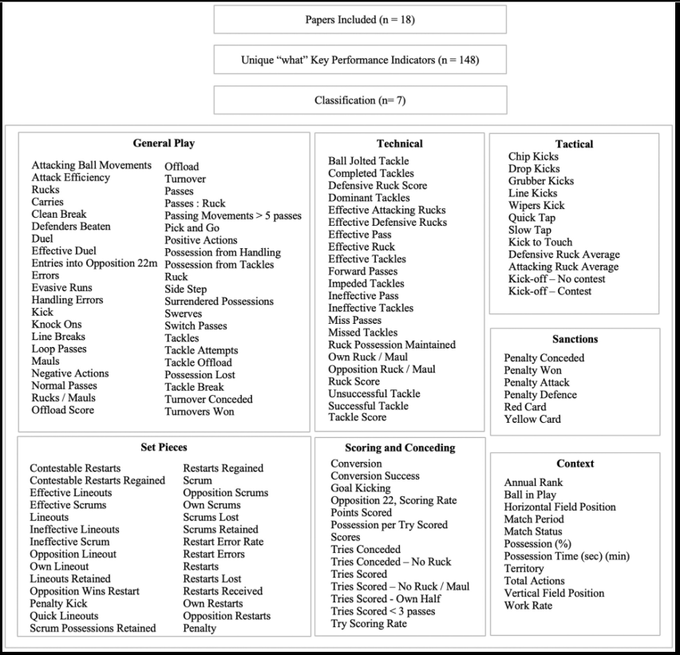
Figure 2.1 Classification of key performance indicators in Rugby Sevens
(Finnegan et al., 2025)
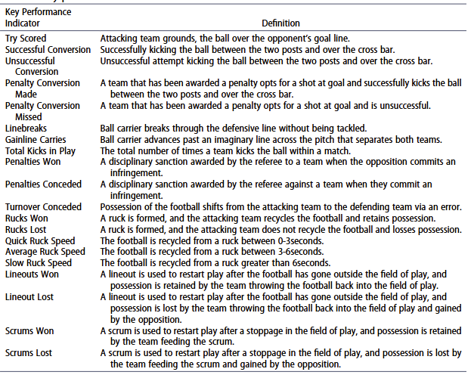
Figure 2.2 Key performance indicator definitions
(Callinan et al., 2024)
These indicators help define whether a strategy is considered successful. For example, if a certain strategy shows in high gain line success and less penalties awarded to the team, it may be seen as more effective than another. In this project, some indicators can be used as a part of the fitness function or as a rules and constraint to evaluate the performance of generated strategies during the GA process. The rules and constraint will add one or two points if it meets the requirement of the rules while opposite for not meet the requirement and will minus the points.

According to a study by Moolman et al. (2025), several performance indicators (PIs) were identified as a strong indicators or factors between winning and losing teams in both Rugby Union (RU) and Rugby Sevens (RS). The study evaluated statistical significance (p-values) and effect sizes (Cohen’s d) to determine the impact of each PI on match outcomes. Although exact numerical thresholds are not explicitly defined. The results clearly show patterns of success among winning teams. In Rugby Union, winning teams were more likely to receive and win restarts, gain possession through line-outs, score more tries, and perform better defensively by committing fewer penalties and missing fewer tackles. Similarly, in Rugby Sevens, the ability to control restarts and score tries were significant. These findings meet with the idea that strategic optimization in rugby should not only focus on offensive plays but also emphasize control of key game events and minimizing errors. Table 2 and 3 below is the summarizes of the main indicators and their relevance to match success in both formats which is RU and RS.

Table 2.2 Key performance indicators (PIs) related to Winning in Rugby Union
Performance Indicator | Significance (p-value) | Effect Size (Cohen’s d) | General Benchmark for Winning
Restarts received | p < 0.001 | d = 1.18 | Winning teams receive more restarts
Restarts won | p = 0.001 | d = 1.21 | Winning teams win more restarts
Line-outs won | p = 0.048 | d = 0.65 | Winning teams win more line-outs
Total line-outs | p = 0.004 | d = 0.96 | More successful line-out executions
Total penalties | p = 0.023 | N/A | Winning teams commit fewer penalties
Missed tackles | p = 0.022 | d = 0.76 | Fewer missed tackles
Tackle completion % | p = 0.029 | d = 0.72 | Higher defensive success
Tries scored | p < 0.001 | d = 1.43 | More tries scored
(Moolman et al., 2025)

Table 2.3 Key performance indicators (PIs) related to Winning in Rugby Sevens
Performance Indicator | Significance (p-value) | Effect Size (Cohen’s d) | General Benchmark for Winning
Restarts received | p < 0.001 | d = 1.56 | Winning teams receive more restarts
Restarts won | p = 0.001 | d = 1.11 | Winning teams win more restarts
Line-outs won | p = 0.013 | d = 0.83 | Winning teams gain more possession
Tries scored | p < 0.001 | d = 2.13 | More tries scored
(Moolman et al., 2025)

- Significance (P-value):
- To show whether the result is important or not.
- If p < 0.05, it means the result is clearly important.
- If p < 0.001, it means stronger evidence that the performance indicator affects the winning. Example: if “tries scored” has p<0.001, it means the tries scored give the big impact for the match results.

- Effect Size (Cohen’s d):
- To tell the size of the different between the winning and losing teams.
- Scale for understanding:
  - 0.2 = small effect
  - 0.5 = medium effect
  - 0.8 or more = large effect.

Table 2.1 and Table 2.2 shows the significance value and effect size (Cohen’s d) for some of the performance indicator in RU and RS. These indicators and their significance values are essential references in determining which parts of the gameplay should be prioritized during strategy optimization. By using these findings, the prototype can apply rules or constraints in the fitness function, such as rewarding strategies that include more tries or give a penalty for those that involve in higher missed tackles.

Table 2.4 Key performance with benchmark
Indicator | Benchmark
Ball-carrier used moderate leg drive | 25% reduction in risk of losing possession (RR = 0.75, 95% CI: 0.58–0.97, p < .05)
Tackler uses moderate leg drive | 53% higher chance of the ball-carrier losing possession (RR = 1.53, 95% CI: 1.09–2.14, p ≤ .05)
One attacker committed to the ruck instead of two | Higher possibility of retaining possession  (RR = 0.31, 95% CI: 0.19–0.49, p < .001)
Active ball placement after tackle (strategic ball placement on the ground during the ruck form) | 14 times more likely to retain possession  (RR = 14.67, 95% CI: 9.55–22.56, p < .001)
(Hendricks et al., 2020)

Another study by Hendricks et al. (2020), Table 2.4 identified several key performance indicators that related to ball possession during contact situations in rugby. Risk Ratio (RR) is used to explain the impact of certain indicators on the chances of retaining or losing possession. If RR value less than 1.0, it suggests a positive outcome or less risk, while a value greater than 1.0 suggests a negative outcome which is increasing the number of risks. For example, when a ball-carrier used moderate leg drive, the team had a 25% lower risk of losing possession (RR = 0.75), which is considered as a helpful action. Then, if the tackler applied moderate leg drive, the results shows that 53% higher chance of the attacking team losing their possession (RR = 1.53). Additionally, when only one attacker committed to the ruck instead of two, the chance of retaining possession increased significantly (RR = 0.31). The most important factor is the active ball placement after a tackle because the benchmark show that the attacking team became 14 times greater probability to retain the ball (RR = 14.67). These indicators show the importance of technical movements during the gameplay that can be used as strategic rules or constraints when evaluating the effectiveness of a rugby strategy in optimization systems.

Additionally, strategy optimization allows rugby teams to explore alternative tactical patterns that may not be obvious through manual planning. By using optimization algorithms, teams can simulate various match scenarios, test strategy performance under different conditions of team and identify the weaknesses before the match day. As highlighted by Dawei (2025), the use of optimization in sports strategy can improve both training and match outcomes by continuously refining tactics based on feedback and measurable performance.

In conclusion, strategies optimization in rugby is essential for improving decision-making and achieving competitive advantages. By using optimization techniques such as GA and applying relevant performance benchmarks, teams can identify and implement more effective strategies. This will support coaches and analysts in moving toward data-driven approaches in game preparation and tactical decision making.

2.4 Genetic algorithm

This prototype will use genetic algorithm as the proposed technique which based on mechanism biological evolution. Genetic algorithm is suitable for this prototype because it is a type of evolutionary algorithm. It will use search technique while try to find the best solution for complex problem, especially in the context of sports strategies which contain a lot of solution and strategies with the fastest way (Ansari & Saubari, 2020). It also popular among the machine learning to find the optimal solution.

According to (Ansari & Saubari, 2020), chromosomes are individuals in one population, which it is a solution in the form of symbol. The initial population will be built randomly and the next population is the evolution of chromosomes. There are 6 main components of genetic algorithm, which include Coding Technique, Initialization Procedure (generate initial population), Evaluation Function, Selection and Generic Operators. While the other study by (Ardana et al., 2024), there are 7 steps to implement the GA including Population Evaluation, Chromosome Evaluation, Selection, Crossover, Mutation, Formation of New Generation and Termination. Besides, in this section, it will focus about explanation on its step by step and component that will be implement during this prototype.

2.4.1 How genetic algorithm works

In this section, the 7 steps will be explained more detailed about the function and how it works during the implementation in the prototype(Ardana et al., 2024).

- Population Initialization

Begin the process by creating an initial population of possible solutions. These solutions will be represented as chromosomes (either in binary, symbols, or arrays). In the context of this prototype, each chromosome represents a complete rugby strategy, while each gene corresponds to a single tactical decision or play, such as pass, run, or kick.

For example, a chromosome like [0, 1, 2, 0, 1] might represent a sequence of plays, for example: Pass → Run → Kick → Pass → Run. This type of format allows the Genetic Algorithm to evolve and optimize different play sequences. The strategies will be generated either randomly or based on specific predefined rules depending on the needs of the prototype.
According to study by (Vinod Babu & Mvp Chandra Sekhara Rao, 2024), for optimize the player selection, the study set 10 individuals as initial population and each population are solution to the problem. Genes is a set of parameters from individual and the joined of the genes are called chromosome.

- Chromosome Evaluation

All the chromosome in the population will be evaluated by using fitness function. The fitness function will be measured how the solution will solve the problem well. It will indicate as the quality of the chromosome. The fitness function is used to figure out how near a given timetable to the best or optimum timetable when it comes to final exam scheduling (Mixer et al., 2025a). According to study by (Vinod Babu & Mvp Chandra Sekhara Rao, 2024), fitness value of chromosome is the sum of all gene values within in a chromosome.

- Selection

Selection is the step where the chromosomes with the highest fitness values are selected to become the parents. They will produce the next generation. The methods that are mostly used are the roulette wheel selection method, tournament selection, and ranking selection. The roulette wheel method gives individuals with the highest fitness values a larger slice, which increases their chance of being selected. Tournament selection randomly selects a group of two or more individuals and picks the best one among them to be a parent. For example, individuals 2, 3, and 4 may be randomly selected, and a comparison of all selected individuals will be conducted to find the one with the best fitness value, who will then become the parent. This method is easy to implement and works well even with small population sizes. Lastly, in ranking selection, individuals are chosen based on their ranking in fitness value. It is suitable when the difference in fitness values is too large (Edison et al., 2024).
- Crossover

In order to create child, the crossover process involves crossing segments between parent chromosomes. Among the popular methods include uniform crossover, two-point crossover and one-point crossover. One-point crossover is used in study by Ansari and Saubari to solve the course scheduling problem. Next two-point crossover method which means choosing two randoms points from the parent chromosomes. It will be swapped between both point part to make a new offspring and it will enable a greater variety of genetic material recombination than single-point crossover. Uniform crossover works by choosing each gene one by one from a single parent at random and matching crossover ensures a high level of genetic variety (Edison et al., 2024).

- Mutation

After the crossover, it will select some offspring and randomly changes part of the genes with a low random probability. The function of mutation is to maintain genetic diversity in the population and it also randomly changing the value of gene (Ardana et al., 2024). There are three mutation operators such as Swap Mutation, Shrink Mutation, and Growth Mutation. Each of the mutation operators have their own way to do the mutation like Swap Mutation will shuffles the array positions, Shrink Mutation will remove a random number from the original one and Growth Mutation will increase the number of array or gene by adding a random number into the gene(Guerrero et al., 2017a). All of these three operators can be seeing in the Figure 2.3 below.

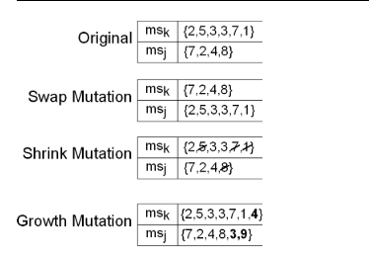
Figure 2.3 Example of three mutation operators
(Source: Guerrero et al., 2017b)

For this prototype aspect, the operators that can be implement are Growth Mutation and Swap Mutation because the purpose of the strategies optimization are to find the effective way and optimal strategies during the match day. Instead of remove the factors to create strategies like shrink operator, other operators are clearly suitable.

- Termination

Termination is the process where it will terminate the chromosomes if it was not producing a new chromosome which is significantly different from the previous generation. It also happens if “n” does not have a new generation. The population evolves by replacing the less fit individuals with better ones in each generation. This process will continues until it met their stopping criteria (Vinod Babu & Mvp Chandra Sekhara Rao, 2024). According to (Ardana et al., 2024), the example of the criteria are when the number of generations reach the maximum limit or when the optimal solution is found.

2.4.2 Advantages of using genetic algorithm

Genetic Algorithm (GA) is one of the best optimization techniques that be used in solving problems which involve a large number of possible solutions. The application is suitable in this project because in the context of rugby strategy optimization, where multiple decisions and combinations of tactical plays need to be considered. GA's advantage is its ability to find nearly perfect solutions using a technique based on natural selection, which includes selection, crossover, mutation and termination.

Several studies have shown that Genetic Algorithm offers a lot of advantages that make it suitable for solving problems related to planning, scheduling, and strategy. This section will discuss about the advantages of genetic algorithm.

GA has shown it strength in solving complex problems, especially in areas that involve strategic decision-making, such as sports. In rugby, coaches are often required to plan a few of tactical actions involving different combinations of passes, runs, and kicks. GA is capable of evaluating these combinations across the multiple generations and can improving the strategy through evolutionary processes. According to Dawei (2025), GA was effectively used to optimize both training and game strategies in basketball. The algorithm produced different tactical sequences and improved it continuously and led to improved team performance. It suggests that GA is well-suited to the flexible tactical of rugby gameplay, where a few options must be evaluated under changing scenarios.

In addition, GA has been shown that it can produce suitable and optimal solutions quickly. Even when there are many conditions or rule need to follow. This is very helpful in sports, where strategy decision making must be made instantly within any various scenarios. According to study by Ansari and Saubari (2020), they found the effectiveness of GA in solving course scheduling problems. It involves a difficult limitation such as lecturer availability and class overlap. The results showed that a complete and valid timetable was produced. The main potential of GA is to produce workable solutions quickly and accurately. In the context of rugby, where strategy development will include fixed player roles and various scenario, the efficiency of GA can be clearly demonstrated.

Moreover, GA will always improve the quality of solving problems, within the process like selection, crossover, mutation and termination. It will improve the efficiency of the solution. In Dawei’s (2025) study, the GA model evolved basketball strategies based on feedback from actual performances. It leads to more effective tactical gameplan. The same concept can be applied in rugby to improve the strategy gameplan and decision-making during the match day.
In conclusion, GA presents an efficient approach to strategic optimization based on the flexibility of solving problems and ability to work in limitation. The research from previous studies suggests that the implementation of GA in this project is both relevant and appropriate, especially for addressing the challenges of rugby strategy optimization in a structured and systematic manner.

2.5 Implementation of Genetic Algorithm in Various Domains

Table 2.5 Implementation of GA in various problem
No | Title |  | Year | Problem | Objective | Technique/Method | Result | Reference
1. | Gradient GA:  Gradient  Genetic  Algorithm for  Drug  Molecular  Design |  | 2022 | Traditional genetic algorithms rely on random walk exploration, leading to slow convergence and unstable final solutions. | To improve convergence speed and solution  quality in molecular design by incorporating gradient information. | Gradient Genetic Algorithm (GGA) combines genetic algorithms with gradient guidance using Discrete Langevin Proposal (DLP) and a differentiable objective function parameterized by a neural network. | Achieves up to 25%  improvement in top-10 scores over vanilla genetic algorithms,  with faster convergence and better solution quality. | (Zhuang et al., 2025)
2. | Two-Stage  Genetic  Algorithm for  Optimization  Logistics  Network for  Groupage  Delivery |  | 2024 | Optimization of groupage  intercity delivery with fluctuating cargo flows  and complex  logistics networks. | Minimize transportation costs by strategically positioning regional branch warehouses and optimizing delivery routes. | Two-stage genetic algorithm (GA) with BaumEvA Python library: Stage 1 for warehouse selection, Stage 2 for vehicle routing problem (VRP). | Achieved cost savings of up to 8.03% compared to expert solutions, with improved terminal utilization rates (90% and 95%). | (Malashin  et al.,  2024)
3. | Improved genetic algorithm based on greedy and simulated annealing ideas for vascular robot ordering strategy |  | 2025 | Optimizing acquisition, utilization, and maintenance of ABLVR vascular robots in healthcare settings | Minimize costs while meeting hospital treatment demand for vascular robots | Hybrid genetic algorithm combining greedy and simulated annealing, ARIMA time series forecasting | Superior optimization, transparency,  and convergence speed  compared to traditional methods | (Wang et al., 2025)
4. | Development of Adaptive Lecture  Scheduling  System using  Genetic  Algorithm  Case Study:  Ahmad  Dahlan  Institute of Technology and Business |  | 2024 | Inefficient manual lecture scheduling in higher  education institutions | Optimize course schedules to avoid clashes and improve resource  utilization | Genetic Algorithm (GA) with Rapid Application  Development (RAD) model | Produced clash-free schedules  efficiently (1-5 seconds) and improved  flexibility for  dynamic changes | (Ardana et al., 2024)
5. | Application of a Genetic Algorithm for  Proactive  Resilient  Scheduling in  Construction  Projects |  | 2022 | Uncertaintyinduced delays and disruptions in construction  projects | Minimize project duration,  maximize  profit, and enhance schedule resilience | Customized Non-  dominated Sorting Genetic  Algorithm-II (NSGA-II) | Generated  resilient  schedules with reduced deviations in duration and profit under uncertainty | (Milat et al., 2022)
6. | Optimization of Genetic Algorithm in  Courses  Scheduling |  | 2022 | Manual scheduling is timeconsuming, inaccurate, and prone to clashes. | To optimize course scheduling using genetic algorithms for efficiency and accuracy. | Genetic Algorithm (GA) with PHP, MySQL, Bootstrap, and Visual Studio Code. | GA produced optimal schedules with no  clashes; first  chromosome had the highest fitness value (1). | (Nasien &  Andi,  2022)
7. | A genetic algorithm tool for conceptual structural  design with cost and embodied carbon optimization |  | 2022 | Manual conceptual design is time-consuming, biased by engineers' expertise, and lacks multi-objective optimization for cost, safety, and environmental impact. | To develop a tool for rapid, optimized conceptual  design of buildings considering cost, free-space, and embodied CO₂ emissions. | Non-dominated Sorted Genetic Algorithm II (NSGA-II) with multi-objective optimization (cost,  span, CO₂), integrated with lateral load system modules. | The tool generated 15–40 feasible  solutions in <2 minutes, validated against benchmarks, showing improved cost and CO₂ efficiency compared to manual designs. | (Kanyilmaz et al., 2022)
8. | Two genetic algorithms for final exam scheduling |  | 2024 | University exam scheduling is complex, with hard constraints (e.g., room capacity) and soft constraints (e.g., minimizing student/faculty | To optimize exam scheduling by minimizing conflicts (faculty, student, and 3-exams-in-one-day) using AI techniques. | 1. Pure Genetic Algorithm (GA): Uses selection, crossover, and mutation on schedules.  2. Mixed Algorithm: Combines graph coloring (Greedy, DSATUR, RLF) with a novel GA for time permutations and schedule mutations. | - Pure GA reduced conflicts but had limitations.  - Mixed Algorithm achieved near-optimal results: 0 faculty/student conflicts and only 3 students with 3 exams in one day (vs. 287 conflicts historically). Implemented successfully at Wentworth Institute. | (Mixer et al., 2025b)
9. | Optimizing Service  Scheduling by Genetic Algorithm Support Decision-Making in Smart Tourism Destinations |  | 2024 | Efficiently managing and  delivering services in smart tourism destinations to meet tourist expectations while upholding sustainability principles. | To explore the application of  genetic algorithms (GAs) in optimizing service scheduling to enhance decision-making and tourism services. | Genetic Algorithms (GAs) for service scheduling  optimization, including selection, crossover, and mutation operations. | GAs significantly  improved service scheduling efficiency, reduced costs by 20%, increased customer satisfaction by 17%, and enabled real-time adaptability to dynamic conditions. | (Suanpang &  Jamjuntr, 2024)
10. | Genetic Algorithm Based on Natural Selection Theory for Optimization Problems |  | 2020 | Conventional genetic algorithms (GAs) suffer from poor control of exploitation and exploration, leading to suboptimal solutions. | To propose a new GA variant (GABONST) that improves exploitation and exploration balance for optimization problems. | Genetic Algorithm Based on Natural Selection Theory (GABONST), incorporating selection, crossover, and mutation with mean-based fitness evaluation. | GABONST outperformed conventional GA, EATLBO, Bat, and Bee algorithms in 13 out of 15 benchmark functions, achieving faster convergence and higher accuracy. | (Albadr et al., 2020)

Genetic Algorithms (GAs) have become a widely adopted method for solving optimization problems across numerous industries. Their robustness and adaptability allow them to tackle problems that are nonlinear, complex, and multi-objective in nature.
One major area of success is logistics and transportation. The Two-Stage GA by Malashin et al. (2024) demonstrated clear benefits in optimizing logistics networks with fluctuating cargo flows, achieving significant cost savings and operational efficiency. Similarly, in the construction industry, Milat et al. (2022) applied a customized NSGA-II algorithm to proactively manage schedule disruptions, improving resilience and project outcomes.

2.5.1 Gradient genetic algorithm for drug molecular design

This study introduced a new method that are call the Gradient Genetic Algorithm (Gradient GA). The purpose is to assist drug molecules design more effectively. Traditional genetic algorithms often move randomly and take more time to find the best solutions compare to this method that introduced. The researchers combined the gradient information with a neural network model for the solution for solve this problem. They used a technique called the Discrete Langevin Proposal (DLP) to guide the search in a smarter way. The method was tested on drug design tasks and the result shows it gives a better performance rather than standard GAs, improving solution quality and speed up to 25%. This method helps pharmacist to find drug like molecules faster and more accurately. It also making it useful in the pharmaceutical field (Mukherjee et al., 2025).

2.5.2 Improved genetic algorithm based on greedy and simulated annealing ideas for vascular robot ordering strategy

In this research, the researcher developed the improve genetic algorithm to optimize how hospitals order and use ABLVR vascular robots. The goal is to reduce costs while fulfil the medical needs. The authors use two different ideas which is greedy strategy and simulated annealing. The algorithm also worked with an ARIMA time series model to predict future demand for robots. Results showed that this improved method gave better solutions compare than normal GAs by lowering costs and improving efficiency. This approach is helpful in healthcare resource planning, especially for new medical technologies like vascular robots (Wang et al., 2025).

2.5.3 Two-stage genetic algorithm for optimization logistics network for groupage delivery

This paper proposed a two-stage genetic algorithm to solve its problems in logistics which is groupage delivery, where the study required to find the best way for shipped items together. In the first stage, the GA picked the best warehouse locations to lower transport costs. While in the second stage, another GA was used to plan a proper route for truck delivery. The main goal was to reduce long-distance and last-mile delivery costs. The results shows that the method was efficient. It could adapt to changing delivery demands. This work is useful in supply chain logistics and delivery planning (Malashin et al., 2024).

2.5.4 Development of adaptive lecture scheduling system using genetic algorithm

This paper study the use of genetic algorithms for adaptive lecture scheduling system at Ahmad Dahlan Institute of Technology. The objective is to optimize course scheduling while considering the dynamic factors like lecturer availability and classroom limitation. The GA-based system works better than traditional scheduling methods because it offers a quicker and more flexible solutions. It also improves the efficiency and a few of scheduling conflicts. The results shows that the system significantly reduces the scheduling time and provides a better flexibility for last-minute adjustments (Ardana, Hastomo, & Arman, 2024).

2.5.5 Application of a genetic algorithm for proactive resilient scheduling in construction projects

This research study about a customized genetic algorithm (GA) to improve the proactive resilient scheduling in the construction industry by focusing on uncertainty and project delays. The goal is to create the baseline schedules with time flexibility to absorb unforeseen disruptions. The GA optimizes scheduling for duration, cost, and overall stability. The results show that the GA successfully generates resilient schedules that improve stability and can handle project uncertainties effectively. It also led to more reliable project timelines and better resource allocation (Milat, Knezic, & Sedlar, 2022).

2.5.6 Optimization of genetic algorithm in courses scheduling

The research is about the application of genetic algorithms to optimize course scheduling in universities. Main issues that state in this study is manual scheduling inefficiency and resource allocation conflicts. The GA-based system successfully finds optimal solutions by reducing the scheduling conflicts between the rooms and the lecturers. The results shows that the GA provides an effective and saving a lot of time to course scheduling compared to traditional methods because it improving in both accuracy and resource management (Andi & Nasien, 2022).

2.5.7 A genetic algorithm tool for conceptual structural design with cost and embodied carbon optimization

This paper discusses about the development of a genetic algorithm (GA) tool based on the Non-dominated Sorted Genetic Algorithm II (NSGA-II) for optimizing conceptual structural design. The objective is to determine the various safe, economical, and low-CO2 options for building designs in a short time. The research focuses on multi-objective optimization which are have a few account factors like cost, embodied CO2 emissions, and space. The results show that the GA tool enables a quick decision-making and provides a large set of optimal design to engineers. In summary, the development of GA improves in cost efficiency and the environmental in building design (Kanyilmaz, Tichell, & Loiacono, 2022).

2.5.8 Two genetic algorithms for final exam scheduling

According to study by (Mixer, Morrow, & Sukherman, 2024), this research paper compares two genetic algorithms (GA) method for final exam scheduling at Wentworth Institute of Technology. One of the GA methods used is pure genetic algorithm while the other one is combination of GA with graph theoretical algorithms. The main objective is to optimize the scheduling process by minimize the faculty and student problems and to optimize only one exam per day. The results shows that the GA methods find a better way compare to the traditional scheduling approach by reducing the problems and improving the scheduling efficiency.

2.5.9 Optimizing service scheduling by genetic algorithm support decision-making in smart tourism destinations

This study by (Suanpang & Jamjuntr, 2024), the use of genetic algorithms for optimizing service scheduling in smart tourism destinations is mainly focusing on improving operational efficiency, customer satisfaction, and stability. The GA methodology is applied to service scheduling in the tourism sector, providing more efficient and flexible scheduling compared to traditional methods. The results shows that the GA significantly improve the scheduling efficiency, reduces the operational costs, and improves customer satisfaction.

2.5.10Genetic algorithm based on natural selection theory for optimization problems

This research proposes a genetic algorithm based on natural selection theory (GABONST). It is designed to address optimization problems by improving the control over the exploration and exploitation phases of the search process. The algorithm is tested on benchmark functions and language identification tasks. The result shows that it much better than traditional genetic algorithms in terms of solution quality. The implementation of the GA with extreme learning machine (ELM) further enhances its accuracy. It achieves up to 99.38% in language identification tasks (Albadr, Tiun, Ayob, & AL-Dhief, 2020).

2.6 Similar works

Table 2.6 Similar Application
No. | Title | Problem | Objective | Technique/  Method | Result | Reference
1. | Using Genetic  Algorithm to  Optimize the Training Plan and Game  Strategy of  Basketball  Players | Traditional basketball training plans and game  strategies rely heavily on coaches’ experience, which may lack precision  and adaptability. | To optimize basketball players' training plans and game strategies using genetic algorithms for improved performance. | Genetic Algorithm for encoding training variables and strategies, fitness functions to evaluate solutions, and iterative optimization. | GA-optimized training and  strategies showed  superior results in player development and team performance  compared to  traditional methods. | (DAWEI,  2025)
2. | Automatic  Group  Organization for  Collaborative  Learning  Applying  Genetic  Algorithm Techniques and the Big Five Model | Forming effective groups in collaborative learning is challenging due to the complexity of balancing multiple student characteristics. | To automate group formation in collaborative learning by considering students’ personality traits using the Big Five model. | Genetic Algorithm with modified crossover (C1) and mutation operators, fitness functions for homogeneity/heterogeneity. | GA-formed groups improved academic performance and collaboration outcomes compared to student preferred or random groupings. | (Sánchez  et al.,  2021)
3. | Application of genetic algorithm concept on course scheduling | Difficulty in allocating courses, lecturers, and rooms without conflicts in university scheduling. | Implement genetic algorithms to improve accuracy and speed in determining class schedules without collisions. | Genetic algorithm with components: coding  techniques, initialization, evaluation function, selection, and genetic operators. | Achieved course schedules without collisions in one iteration,  though minor conflicts  remained due  to small initial population size. | (Ansari &  Saubari,  2020)
4. | Bio-inspired resource allocation optimization using evolution based genetic algorithm for vocational education skill development: A natural selection approach | Efficient distribution of limited educational resources to maximize learning outcomes in vocational education. | Develop a multi-objective optimization model for resource allocation balancing educational effectiveness, efficiency, and equity. | Genetic algorithm with adaptive parameter tuning, dynamic niche techniques, and real-time performance feedback. | Improved resource  utilization efficiency by 27.3%, achieved 92.3% goal  satisfaction, and outperformed traditional methods  significantly (p < 0.001). | (Meng & Li, 2025)
5. | Evolving  Fantasy  Cricket  Teams:  Applying  Genetic  Algorithms for  Optimal  Player  Selection | Suboptimal team selection in fantasy cricket due to inefficient exploration of solution spaces. | Optimize fantasy cricket team selection using genetic  algorithms to maximize performance within budget and role constraints. | Genetic algorithm with selection, crossover, and mutation operations, compared to random sampling, systematic replacements, and Kmeans clustering. | GA outperformed other methods with a 74.6 average team score, 98% credit utilization, and high consistency. | (Vinod  Babu &  Mvp  Chandra  Sekhara  Rao, 2024)
6. | Optimization study of students’ physical training program in  volleyball course based on dynamic planning | Inefficient physical training scheduling for volleyball students, leading to suboptimal performance and time management. | Develop a dynamic programming model to optimize physical training schedules, minimizing time and maximizing fitness outcomes. | Genetic algorithm with adaptive crossover/mutation, penalty functions, and sequential fitness transformation. | Achieved optimal training schedules, reducing time and improving fitness metrics (e.g., step test and lung capacity) compared to  traditional methods. | (Hao et al.,  2025)
7. | Optimizing the best play in basketball using deep learning | Difficulty in identifying the optimal offensive play and shooter in basketball under defensive pressure. | Predict the best offensive play and shooter to maximize the probability of scoring in critical game situations. | Deep learning (multi-layer neural network) with feature vectors and Expected Possession Value (EPV) calculations. | Achieved 75.6% accuracy in predicting successful plays, with an  F-measure of 84.62%, enabling realtime decisionmaking for coaches. | (Javadpour  et al.,  2022)
8. | Research on  Optimization  Design of  Physical  Education  Curriculum  Structure  Based on Genetic  Algorithm | Traditional physical education course structure struggles to  adapt to modern standards due to constraints like class time, teachers, and classrooms. | Optimize the physical education course  structure to maximize resource utilization and minimize conflicts. | Improved genetic algorithm combined with simulated annealing for crossover and mutation operations. | The improved genetic algorithm achieved higher fitness function values than  the traditional method, resolving conflicts and improving resource utilization. | (Su et al.,  2024)
9. | Enhancing Students' Physical Fitness  Through  Optimized Training based on Genetic  Algorithm | Declining physical fitness among students, inefficiency in traditional physical training methods, and lack of modern training techniques. | Improve students' physical fitness and test scores by optimizing  training  methods and  load arrangements. | Genetic algorithm combined with IoT for data collection, optimized training load, and modern  physical training techniques. | The optimized training improved students' endurance, strength, and coordination, with significant gains in test scores  compared to  traditional methods. | (Lu, 2024)
10. | Research on the  Application of  Improved  Genetic  Algorithm Based on  Physical  Education  Teaching | Inefficient and suboptimal scheduling of physical education curricula due  to limited resources and time constraints. | Optimize physical education course scheduling using an enhanced genetic algorithm to improve efficiency and solution quality. | Improved genetic algorithm incorporating chaos theory for population initialization, crossover, and mutation. | The chaotic genetic algorithm outperformed the traditional version, achieving faster convergence and higher quality solutions for course scheduling. | (Liu & Yang,  2024)

Many studies have used genetic algorithms (GA) to improve strategies and performance in sports, and some of these methods can be applied to rugby. All of these studies helping in how GA can optimize things like team strategies, training schedules, and player performance.

According to study by Ansari and Saubari (2020) they used genetic algorithms to solve scheduling problems in universities. The results showed that GA could help organize time scheduling and resources effectively. GA also can avoid from any conflicts. Although this study about course scheduling, the idea of organizing resources can be applied to optimize the rugby team strategy.

Another study by Revelo Sánchez et al. (2021) used GA to form teams for group work in educational settings while considering the personality traits of the students. This method is helping for create teams with the right skills and personalities. In the context of rugby, GA can help choose the best strategies for a team during the match day.

In another study, Meng and Li (2025) used GA to improve how educational resources were distributed in vocational schools. Their approach helped allocate resources in a way that was both efficient and fair. This idea can be applied to rugby by balancing tactical play and player resources to get the best strategy results.

For improving team performance, Qiu (2025) used GA to optimize basketball training plans and game strategies. This method helped coaches adjust their training based on real-time data. The result shows that by using GA, they are improving player skills and team performance. A similar approach can be used in strategy rugby to make better decisions about training or game strategies.

Lastly, Liu and Yang (2024) combined GA with chaotic mapping to improve physical education planning. This made the algorithm more efficient and able to find better solutions. These improvements can help optimize rugby strategy by ensuring that the process is effective and adaptable.

In summary, these studies show how genetic algorithms are effective in improving strategies and performance in different areas of sports. By using similar methods, this project can apply a lot of things based on the previous study to optimize strategies for a rugby team.

2.7 Implication of literature review

In the context of this project which is optimizing rugby team strategies using Genetic Algorithm, the reviewed literature provides a lot of information regarding the method that will be used. Several works (DAWEI, 2025; Javadpour et al., 2022; Hao et al., 2025) shows that GAs is highly effective for sports to optimize problems such as training plans, game strategies, and real-time decision-making. The success of GA-based approaches in basketball, volleyball, cricket and general physical fitness optimization highlights their potential to improve strategic planning and player performance in rugby as well. Moreover, the focus on hybrid or new techniques such as combining GAs with deep learning or simulated annealing can improve the robustness and adaptability of rugby strategy optimization. Additionally, it helps on identifying some indicators that will be used within the GA during the evaluation to make sure the strength of the strategies optimization. Based on the observation, this project will modify GA components including encoding of strategies, fitness evaluation criteria and flexible operators to the specific requirement of rugby gameplay. The goal is to develop an optimized strategy framework that supports coaches and analyst in the field when making data driven to get a higher rugby teams’ performance.

2.8 Conclusion

This chapter has discussed many previous studies about the Genetic Algorithm (GA) and how it is used to solve difficult problems in various domain, especially in sports. GA is a useful method that can help find good solutions for planning, scheduling, and making decisions. Based on the literature review, it is clearly shown that GA has been used successfully in many fields like sports, education, and logistics. It can improve strategies, training, and performance by testing and improving solutions over time. These studies show that GA is suitable to be used in this project to optimize the rugby strategies and strategies rugby itself have some indicators to confirm the winning and losing of certain teams. The indicators that will be used in the evaluation will discussed in the next chapter. The main parts of GA such is how to represent strategies, how to measure fitness, and how selection, crossover, and mutation work will be used and modified for this project. Lastly, the knowledge from this chapter will help in building a prototype that supports rugby coaches and analysts to plan better strategies and improve team performance.

CHAPTER 3

RESEARCH METHODOLOGY

This chapter explains the methodology that applied in this project. It will briefly explain about each phase in research framework in more detail. It will highlight the main components of this prototype system before the implementation phase.

3.1 Overview of research methodology

3.1.1 Research framework

This section will explain about the research framework that divided into three phase which are the preliminary phase, design and implementation phase and testing and evaluation phase as shown in Table 1 below. Each of the phase is design to achieve the project’s objective by using the proposed algorithm.

The first phase or preliminary study is the main phase and very important to develop the prototype successfully. It will cover for the entire research project. In the preliminary study phase, the main objective of this phase is to identify the application of genetic algorithm (GA) on the strategy optimization. Hence, to achieve this objective, literature review is applied during the phase. It provides a full of understanding about how the prototype system flow with the proposed algorithm. Reading books, articles, watch videos related to GA, sports optimization and similar works in YouTube are the activities inside literature review. At the end of the literature review, it will help to find the background of the study, specific objectives, the problem during the study or algorithm, potential method that will be applied on the proposed algorithm and identified a suitable testing method. Additionally, the critical part of this phase is data pre-processing, where the data collection will be conducted to gain information for the future use of prototype.
Next, the second phase of research framework also known as design and implementation phase is design to achieve the second objective which is to develop a GA-based system for optimizing strategies in Malaysian rugby teams. In this phase, system design and development will be conducted including define the system requirements and specifications, design and develop the user interface and the implementation of GA modules. A development of a prototype for strategies optimization for rugby team using genetic algorithm. This phase also includes a design system architecture, data understanding and design a project’s Gantt chart for achieve the outcome which is the prototype system flow diagram, the possible strategy rugby representation and well-planned project activities and duration.

Lastly, the last phase is testing and evaluation phase which is to evaluate the performance of GA-based system for optimizing rugby strategies. This phase will involve with the testing of the prototype by using the dataset collection, calculate the highest fitness score and evaluate the effectiveness of strategy suggestions. As a result, the outcome will be the full performance evaluation report, highest fitness value and the possible improvements for this prototype.

Table 3.1 Detailed Research Framework
Research Methodology | Objective | Task | Activities | Outcome
Phase 1:  Preliminary Study | Objective 1:  To identify the application of Genetic Algorithm (GA) in the strategy optimization. | Literature Review | - Reading articles, books and journals  - Watch videos (e.g., YouTube) related to GA and sports strategy optimization | - Background of study  - Problem Statements  - Research Objectives  - Research Significance  - Identification of potential methods  - Testing methods
 |  | Strategy Rugby Understanding | - Interview session with Coach Alias from Universiti Teknologi Petronas (UTP) | - Indicator of the rugby strategies
 |  | Data Collection | - Data pre-processing  - Data cleaning | - Collecting Data Information
Phase 2:  Design and Implementation | Objective 2:  To develop a GA-based system for optimizing strategies in rugby teams. | System Design & Development | - Design a system architecture  - Data understanding  - Design a project’s Gantt chart | - Prototype system flow diagram  - Representation of possible rugby strategies  - Well-planned project activities and duration
 |  |  | - Define system requirements and specifications  - Design and develop the user interface  - Implement GA modules (selection, crossover, mutation) | - Developed prototype for strategies optimization system using Genetic Algorithm
Phase 3:  Testing and Evaluation Phase | Objective 3:  To evaluate the performance of GA-based system for optimizing rugby strategies. | Performance Evaluation | - Test prototype by using the dataset collection  - Calculate the highest fitness score after selection, crossover and mutation  - Evaluate the effectiveness of strategy suggestions | - Performance evaluation report  - Highest fitness value  - Possible improvements

3.2 Preliminary phase

3.2.1 Literature study

The literature study phase is one of the main components during the preliminary phase. Without this activity, the understanding regarding genetic algorithm and strategies optimization will be limited. By reviewing the existing academic article with the closest area of interest and same domain, it highlights the limitation from the previous research and helps in better understanding of this project. Additionally, by reviewing the similar applications article in various problem helps a lot in terms of understanding the technical part of GA and optimization techniques. This phase has been done by using an online academic database such as Google Scholar, Science Direct, IEEE Explore and etc, while platform YouTube also been used to understanding the concept of GA. Hence, the purpose of this phase has been achieved. which is to identify the application of genetic algorithm (GA) in the strategy optimization.

3.2.2 Interview session

During the phase, one interview session has been conducted with Mr. Alias bin Osman as a professional coach from Universiti Teknologi Petronas (UTP). The interview session was conducted online using google meet and the session was fully recorded. It lasted for almost an hour. Coach Alias mentioned that there are several things or parts that really affected in making a rugby strategy and making the strategy successful. It involves opponent strength, team performance and advantages of team itself. Then, he said that the level of the tournament or match also can be included as factors of creating the good strategies. For example, in the local match he used three types of strategy which are basic play, tactical play and contingency play. From the interview session, it proves that majority of the coach rely on their experience. Also mentioned that to make the strategy success, the healthiness of the player should be considered, good time management and good field condition and weather. The main parts that he said is the player attributes give a lot of effects for the team in winning or losing any match. Therefore, it seems align with the literature study part. Figure 3.1 below is the screenshot during the online interview session with the professional coach Mr. Alias.


Figure 3.1 Screenshot of Interview Session

3.2.3 Data collection

Data collection is other main components during the preliminary phase which involve two activities which are data pre-processing and data cleaning. It is very important for a successful prototype developed. A proper data collection process helps in improving the accuracy of the data which is important in finding the best solution for strategy optimization. Figure 3.2 shows the dataset for statistic of best rugby player in 2023 and 2024.
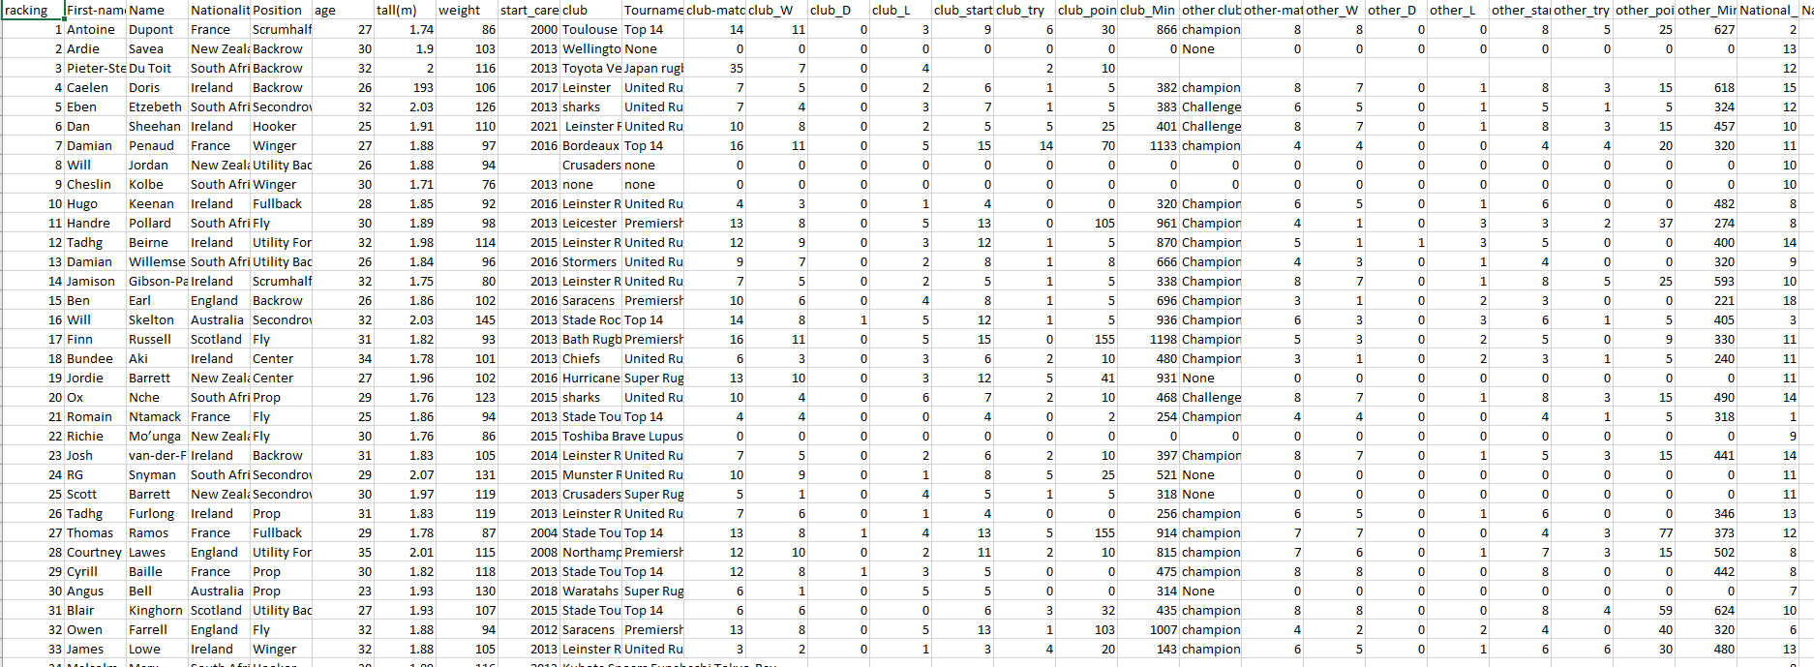
Figure 3.2 Statistic of best Rugby Player in 2023/2024

There are total of 38 attributes and consists of 99 rugby players (instances) which included in the dataset for developing this prototype. The data was obtained from Kaggle which is a trusted public source website. However, not all attributes will be used in the final dataset. Therefore, the data must go through a data pre-processing phase to filter and select only the relevant information.

3.2.4 Data pre-processing

In the data pre-processing, the selected attribute will be identified and unnecessary attributes that do not contribute in the prototype such as racking, National_Starter, National_L, other_starter, other_L and others will be removed. Only the important attributes will be retained and used. After retained the important attributes, the dataset will be review to find if it has any missing value or incomplete data in the rows or columns. Then, data cleaning process will be conducted to remove the zero values and handles any missing values with replacing them.

3.3 Design and development phase

3.3.1 System architecture

The system architecture of this project outlines the structure of how the rugby strategy optimization system functions. It includes a few components such as the user interface for strategies input, the data processing module to handle and prepare the dataset and the Genetic Algorithm module that performs selection, crossover, mutation and fitness evaluation. The system also connects to a database that stores player data and strategy rules. All of the components work together to generate optimized strategies based on the input and predefined performance indicators.

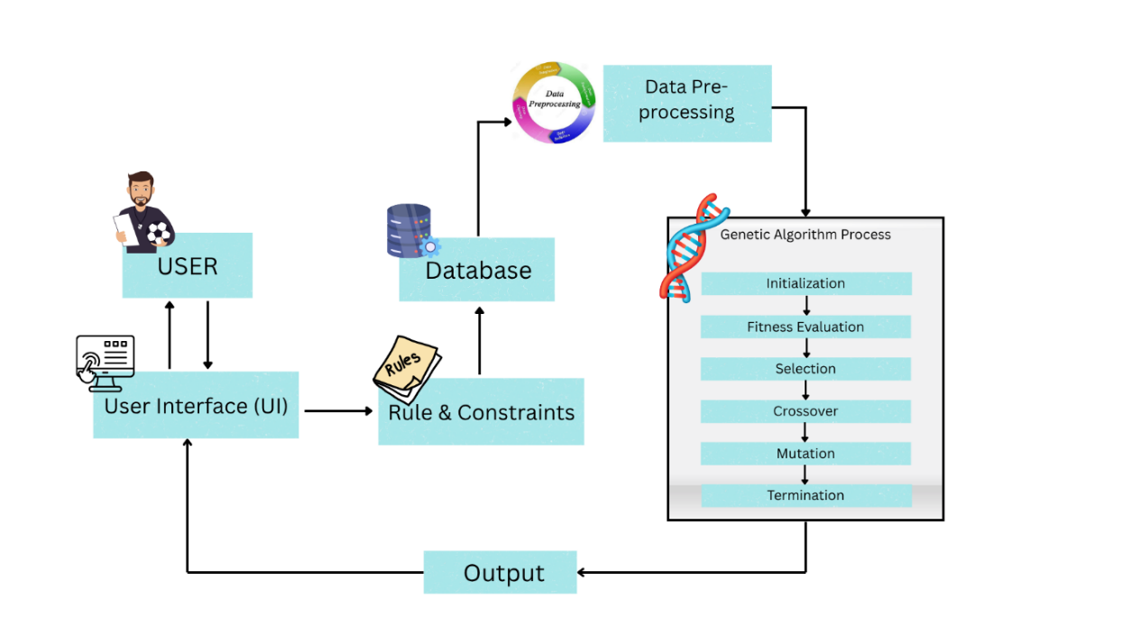
Figure 3.3 System Architecture

Based on Figure 3.3, the system architecture of this prototype is designed to optimize rugby strategies using a Genetic Algorithm (GA). The process begins with the user where they need to inputs a specific rugby strategy such as passing, running, dropkick, or gaining possession through the user interface (UI). Interface role is to communicate between the user and the system. Once the user enters the strategy input, the data will check the requirement needed for pass or not in the rules and constraint module. If it passes or fail, it will remark the points given and carry into the evaluation parts. Then it will go to the database. The database stores all relevant information, including player attributes, tactical actions, and previous match indicators. This data is important to ensure that only valid and meaningful strategies are processed. Next, the data is sent to the data pre-processing module to remove unnecessary attributes handles any missing values and the raw data is encoded into chromosomes for the Genetic Algorithm.

Next, the cleaned data goes into the GA’s module, which consists of several main steps. It starts with initialization, where it randomly generates a population of potential strategy combinations or chromosomes. Then, each chromosome is evaluated using a fitness function based on performance indicators and match constraints. The fittest individuals are selected in the selection step to become parents. Then, it followed by Crossover, where new strategies are created by combining parent chromosomes and go through mutation to maintain diversity. Last of the GA’s module is termination. Finally, the optimized rugby strategy is sent to the output module, which is the final strategy was optimized and it will display back to the user through the User Interface.

3.3.2 Algorithm flowchart

The algorithm flowchart shows the step-by-step process of how the Genetic Algorithm works in this prototype. The flowchart helps to clearly visualize the overall logic of the optimization process. It also can help in the development of this prototype with a better understanding of genetic algorithm process as shown in Figure 3.4 below.
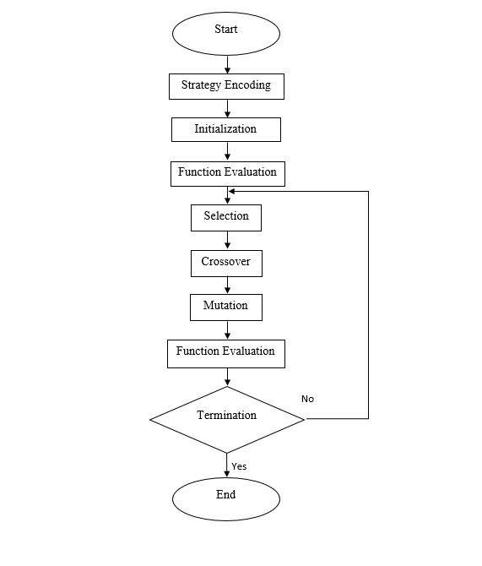
Figure 3.4 Flowchart of Genetic Algorithm

3.3.3 User interface design

Interface design is the process of creating an interesting user interface for end users for a better user experience and user-friendly. It can help the user to understand what need to be done inside the system and guide the users.
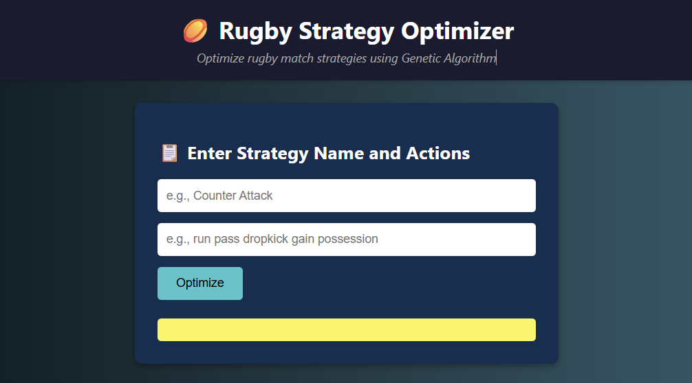
Figure 3.5 Example of strategies optimization prototype user interface

From Figure 2, it shows a simple and user-friendly user interface for strategies optimization prototype. The interface is designed to easier the coach and analyst to use it. Only by view the interface user already know that they need to insert the strategy name and strategy actions inside the form. Then, they only need to click the button “Optimize” to suggest a best solution for the rugby strategy. After that, the output will display under the button “Optimize”.

3.3.4 Pseudocode of genetic algorithm

The pseudocode is an essential part of this prototype development because it outlines the technical or logical steps of the algorithm. It helps in determine whether the part that will do the genetic algorithm process. With this pseudocode, it gives a clear guide during the prototype development as shown in the table 1 below.

Table 3.2 Pseudocode of Genetic Algorithm
Begin
// Step 1: Initialize population
Initialize a population of chromosomes (strategies) randomly or based on predefined rules
Evaluate the fitness of each chromosome
While (termination condition not met) do:
// Step 2: Selection
Select parent chromosomes based on fitness (e.g., tournament selection or roulette wheel)
// Step 3: Crossover
Apply crossover operator to selected parents to produce offspring
// Step 4: Mutation
Apply mutation operator to some offspring to introduce variation
// Step 5: Fitness Evaluation
Evaluate the fitness of new offspring
// Step 6: Replacement
Select individuals for the next generation (e.g., replace worst with best offspring)
End While
// Step 7: Return the best solution
Return the chromosome with the highest fitness value as the optimized strategy
End

Based on the pseudocode above, the Genetic Algorithm (GA) outlines an iterative approach to find the most optimal rugby strategy. The algorithm begins by initializing a population of strategies in chromosomes which are randomly generated or based on predefined rules. Then, each strategy is evaluated using a fitness function to determine its effectiveness. Next, the algorithm selects the fittest chromosomes as their parents using selection methods like tournament or roulette wheel. These parents undergo crossover to produce offspring and some offspring are further modified using mutation to maintain the diversity in the population. The fitness of the new offspring is doing a replacement step selects the best individuals to carry forward into the next generation. This process repeats until the termination condition is met, such as reaching the maximum number of generations or finding a fittest strategy. Finally, the best fitness chromosome is display or choose as the optimized rugby strategy.

3.3.5 Strategy and attribute mapping

There are 3 types of play based on interviews with UTP coaches, namely basic play, tactical play and contingency play. Basic play or general play is a strategy that is played at the start of the game or when the intensity level is moderate. (4) strategies are classified under basic play:
- Scrum
- Lineout
- Ruck
- Tackle

Meanwhile, tactical play is used when playing against teams that are at the same level or stronger. There are 7 tactical plays that will be used, namely:
- pick and go
- grubber kick
- drop kick
- cross kick
- quick tap
- maul
- defensive play

Contingency play is also used during critical moments or during unexpected situations, such as when there are 2 minutes left before time runs out or a player runs out of stamina, injuries, when tactical play cannot be used or when our team on the opponent's 22-metre line.
- Side Step
- Quick Tap
- Chip Kick
- 22-Metre Opponent Scrum

Every of the three strategies in basic play, tactical play and contingency play has their own attribute that will optimize the maximum number of the chosen attribute. These attributes are selected based on the requirement for each strategy for example in scrum in basic play need a lot of strength from position forward. Then, while tactical play and contingency play more to experience player, where a highest total of minutes played (national_min + club_min) will be chosen because it shows the maturity of the player inside the game. With this attribute to select players whose data maximizes the defined attribute ranges; it will make the strategy successful to implement. In the end of the system, it able to optimize the strategy with the most capable of players.

Table 3.3 Basic Play mapping
 | Basic play
Strategy | Attribute from dataset | Range attribute
Scrum | Position, Weight, height | Position: Prop, Hooker, Secondrow  Weight: ≥ 105 kg  Height: 1.80 – 2.05 m
Lineout | Position, height, starter | Position: Secondrow, Backrow  Height: ≥ 1.95 m  Starter: ≥ 6
Ruck | Position, Weight, starter | Position: Backrow, Prop, Hooker  weight 100 – 120 kg  starter ≥ 6
Tackle | Position, Weight, height | Position: Secondrow, Backrow  Weight: ≥ 80 kg  Height: ≥ 1.85 m

Table 3.4 Tactical Play Mapping
Tactical Play | Attribute from Dataset | Recommended Range
Pick and Go | position, weight, height, club_starter | Position: Prop, Hooker, Backrow  weight: ≥ 100 kg  height: 1.80 – 1.95 m  club_starter: ≥ 15
Grubber Kick | position, weight, height, age, club_points | Position: Flyhalf, Scrumhalf  weight: ≤ 95 kg  height: 1.70 – 1.85 m  age: ≤ 28  club_points: ≥ 10
Drop Kick | position, age, club_points, national_points, starter | Position: Flyhalf  age: ≥ 28  club_points: ≥ 20  national_points: ≥ 10  starter: ≥ 10
Cross Kick | position, height, starter, National_min+club_min | position ∈ [Flyhalf]  height ≥ 1.75 m  starter ≥ 10  club_points ≥ 15  National_min+club_min: highest
Quick Tap | position, weight, age, club_try, National_min+club_min, starter | Position: Scrumhalf, Fullback  weight: ≤ 90 kg  age: ≤ 25  club_try: ≥ 3  starter: ≥ 6  National_min+club_min: highest
Maul | position, weight, height, club_starter | Position: Prop, Secondrow, Hooker  weight: ≥ 105 kg  height: ≥ 1.85 m  club_starter: ≥ 15
Defensive Play | position, weight, height, yellow_card, red_card club_min, national_match | position ∈ [Backrow, Lock, Hooker]  weight ≥ 105 kg  height ≥ 1.85 m  yellow_card = 0  red_card = 0  club_min ≥ 600  national_match ≥ 5

Table 3.5 Contingency Play Mapping
Contingency Play | Attribute from dataset | Attribute range
Side Step | position, national_try, national_min + club_min, weight, height, | Position: Wing, Fullback  Weight: ≤ 90 kg  Height: 1.70 – 1.85 m  starter ≥ 6
Quick Tap | position, age, national_min + club_min, national match | Position: Scrumhalf, Wing  weight: ≤ 90 kg  height :1.70 – 1.85m  starter: ≥ 6
Chip Kick | position, weight, height, starter | Position: Flyhalf, Fullback  Weight: 90 – 100 kg  Height:1.75 – 1.85m  Starter: ≥ 10
22m Opponent – Scrum | position, weight, height, starter | Position: Prop, Hooker  Weight: ≥ 105 kg  Height: 1.80 – 2.00 m  Starter: ≥ 10

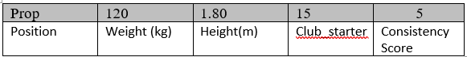
Figure 3.6 Example of Gene for Player 1 of Pick and Go Strategy
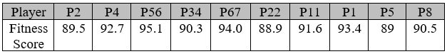
Figure 3.7 Example of Chromosomes for Strategy Pick and Go and 10 Players

Figure 3.6 show the example of gene from player 1 for “Pick and Go” strategy, where it has position, weight(kg), height(m), club_starter and consistency score as the gene. The gene are differently choose based on the Table 3.4, Table 3.5 and Table 3.6, basically every strategy have their different gene for player. While Figure 3.7 show the example of chromosomes for strategy “Pick and Go” for exactly 10 players (gene). The chromosomes will randomly be generated during the initialization step and then it will calculate the highest fitness score for each player. After that it will do the rest process of GA to identify the highest overall fitness score for the chosen strategy.

After the prototype selects the 10 best players suitable for each chosen strategy, the top players from each strategy pool are combined into a single team. This ensures the final team has strategic flexibility and can effectively execute multiple plays during a game. For example, if the coach decides to build a team that can utilize four strategies which are “Pick and Go,” “Cross Kick,” “Grubber Kick,” and “Quick Tap”, the system will select a number of top players from each strategy chromosome and combine them into one balanced team. Furthermore, the selection process also considers the match format, such as 10’s or 15’s, where the system automatically divides the players into forward and backline positions based on standard rugby formations (e.g., 5 forwards and 5 backline for 10’s, or 8 forwards and 7 backline for 15’s). This method ensures that the final team is not only optimized for multiple strategies but also follows proper positional structure, making it more practical for real match scenarios.

3.4 Performance evaluation

3.4.1 Fitness function

$$f\left(c\right)=\sum_{i=1}^{n}{ (\frac{a_{k}​​}{b_{k}}⋅w_{k}​)+S(c)}$$
- f(c) = The fitness score of a player for a given strategy
- $a_{k}$ = The actual value of attribute k from the player (e.g., weight = 110 kg)
- $b_{k}$= The ideal or reference value for attribute k, based on the requirement of the selected strategy (e.g., ideal weight = 120 kg)
- $\frac{a_{k}​​}{b_{k}}$ = reward if met the rules requirement
- $w_{k}$ = Weightage of attribute k, based on its importance in the strategy
- n = Total number of attributes used in the strategy
- $S(c)$= Consistency score, calculated as:

$$S\left(c\right)=\left(\frac{Total Try}{Total Match}\right) ×10$$

Formula Explanation

Assume that the system needs to choose 15 best players for strategy pick and go.

Criteria or requirement for the “Pick and Go”:
- Position: Prop, Hooker, Backrow
- weight: ≥ 100 kg
- height: 1.80 – 1.95 m
- club_starter: ≥ 15

Step 1: Initialization

- Choose a full of dataset with contain 100 players
- Create random of team or population, [e.g.: 5,10,20,30,50)

Table 3.6 Example of 5 population
Chromosome_1= [p1, p2, p3, p4, p5, p6, p7, p8, p9, p10, p11, p11, p12, p13, p14, p15] – (15 players)
Chromosome_2= [p23, p42, p31, p14, p25, p16, p71, p83, p39, p10, p1, p19, p12, p53, p74, p95]
Chromosome_3= [p11, p21, p31, p41, p51, p61, p71, p81, p91, p25, p35, p23, p12, p33, p24, p55]
Chromosome_4= [p19, p29, p39, p49, p59, p69, p79, p89, p99, p12, p22, p33, p44, p44, p66, p77]
Chromosome_1= [p81, p72, p63, p54, p35, p46, p17, p28, p9, p10, p31, p41, p2, p63, p44, p15]

Step 2: Fitness Evaluation

Calculate fitness score for one player from chromosome_1 which is player (p1):

Table 3.7 Fitness Function Calculation
Attribute | Player data | Ideal value | Weight | Calculation
Position | Prop | yes | 30 | 30
Weight | 110 kg | 120 kg | 25 | (110/120)25=22.9
Height | 1.92 m | 1.95 m | 25 | (1.92/1.95)25=24.6
Club_starter | 14 | 15 | 10 | (14/15)10=9.3
Consistency = Try/match | 4/8=0.5 | x 10 | 10 | 0.5 x 10=5

Fitness score_p1 = 30+22.9+24.6+9.3+5 = 91.8
Repeat it for all player inside chromosome_1
Calculate sum of fitness score to get Fitness_team_1

Step 3: Selection

Choose 50% from the population team based on the highest fitness score to become parents.

Step 4: Crossover

Swap players from parents A and parent B
Parent A: [p1, p2, p3, p4, p5, p6, p7, p8, p9, p10, p11, p11, p12, p13, p14, p15]
Parent B: [p23, p42, p31, p14, p25, p16, p71, p83, p39, p10, p1, p19, p12, p53, p74, p95]
Child = [ p23, p42, p31, p14, p25, p8, p9, p10, p11, p11, p12, p13, p14, p15]

Step 5: Mutation

Change 1 or 2 player inside the child
Child before = [ p23, p42, p31, p14, p25, p8, p9, p10, p11, p11, p12, p13, p14, p15]
Mutation change p23 to p1
Child after = [ p1, p42, p31, p14, p25, p8, p9, p10, p11, p11, p12, p13, p14, p15]

Step 6: Termination

- Ga will stop after:
- 50 generation are achieved
- no improvement in 10 generation
- it reaches the highest fitness value >95 or =100

Example Output

- 15 best player that can make the strategy “Pick and Go” succeed
- Best player = [ p1, p42, p31, p14, p25, p8, p9, p10, p11, p11, p12, p2, p14, p15]
- Fitness score = 96.2

Step 7: Convergence graph

The convergence graph is used to show the results of the improvement of the rugby team strategy over generations. It is to show how was the GA significantly maximizes the fitness score until it optimal. Figure 3.6 below show the example of convergence graph

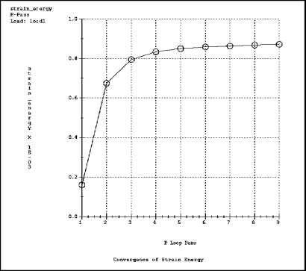
Figure 3.8 Example of Convergence graph
(Strategy: Using Convergence Graphs to Review Results, n.d.)

Do for every population [5,10,20,30,50] and compare it.
Convergence graph will show the graph is consistency increase and static in the end of population

Step 8: validate output

Next run the GA at least 30 time for each population, so that store the data of the maximum fitness value from each population and calculate the accuracy:

$$Accuracy=\left(\frac{Fitness GA Output}{Manual Ideal Fitness}\right)×100\%$$

- Fitness GA Output: maximum fitness value for each population
- Manual Ideal Fitness: summation of score for maximum attribute that are totally same with the ideal value (e.g., p1_weight = 120kg and the ideal weight is 120kg)

Table 3.8 Example calculation for accuracy
Population | Run | Fitness | Accuracy (%)
10 | 1 | 85.5 | 90
10 | 2 | 89.3 | 93.99
10 | 3 | 91.2 | 95.99
10 | 4 | 94 | 98.95

3.5 Project planning

3.5.1 Gantt chart

This section applies a Gantt chart to show the project's timeline for the Final Year Project. For properly organized progress and in time completion, it divides the work into phases, such as planning, writing, development, evaluation, presentation, and submission. Each phase has been scheduled for a particular period of weeks. Hence, Figure 3.6 below show the Gantt chart for this project.

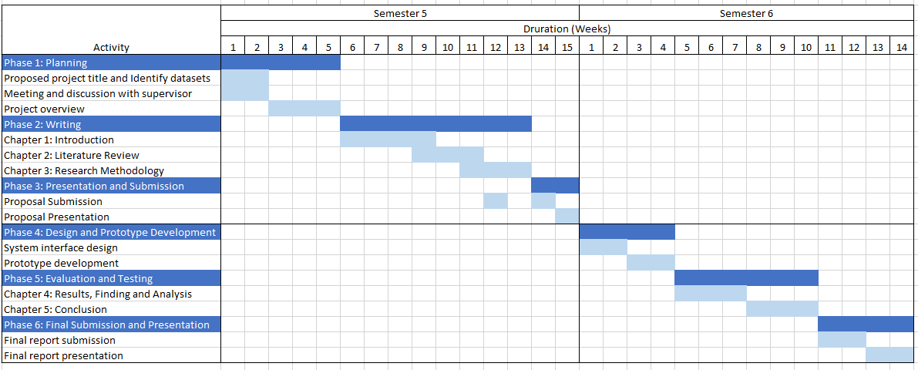
Figure 3.9 Project's Gantt chart

3.6 Conclusion

In conclusion, this chapter has outlined the research methodology used for the development of a strategies optimization for rugby team system using Genetic Algorithm (GA). It begins with the preliminary phase, which involved literature study and data collection to understand the application of GA in sports strategy. The design and development phase described the system architecture, data pre-processing, and the step-by-step implementation of GA, including key operations such as selection, crossover, mutation, and fitness evaluation. The pseudocode and algorithm flow provided a clear guide for system implementation and ensuring a structured approach to problem solving. The calculation of fitness function will find the best or fit player for strategies and the fit player will be recorded for each population. To show the GA system is functioning well, convergence graph will be conducted and to calculate the accuracy of the output, it will run at least 30 time to see the accuracy of the output. Through this methodology chapter, the project aims to produce an effective prototype that can assist coaches and analysts in making better strategic decisions for rugby performance optimization.

REFERENCES
Albadr, M. A., Tiun, S., Ayob, M., & Al-Dhief, F. (2020). Genetic algorithm based on natural selection theory for optimization problems. Symmetry, 12(11), 1–31. https://doi.org/10.3390/sym12111758
Ansari, R., & Saubari, N. (2020). Application of genetic algorithm concept on course scheduling. IOP Conference Series: Materials Science and Engineering, 821(1). https://doi.org/10.1088/1757-899X/821/1/012043
Ardana, N., … W. H.-J. of C., & 2024, undefined. (2024). Development of Adaptive Lecture Scheduling System using Genetic Algorithm Case Study: Ahmad Dahlan Institute of Technology and Business. Journal.Ypidathu.or.IdNB Ardana, W Hastomo, SA ArmanJournal of Computer Science Advancements, 2024•journal.Ypidathu.or.Id, 2(4). https://doi.org/10.70177/jsca.v2i4.1310
Callinan, M. J., Connor, J. D., Sinclair, W. H., & Gómez, M. Á. (2024). Performance metrics that matter: assessing winning and losing teams in women’s Rugby union. International Journal of Performance Analysis in Sport. https://doi.org/10.1080/24748668.2024.2348268;REQUESTEDJOURNAL:JOURNAL:RPAN20;WGROUP:STRING:PUBLICATION
DAWEI, Q. I. U. (2025). Using Genetic Algorithm To Optimize the Training Plan and Game Strategy of Basketball Players. Scalable Computing, 26(1), 441–449. https://doi.org/10.12694/scpe.v26i1.3845
Edison, F. N. E., Marcela Mosquera, E., Berenice Arguero, T., & Julio Zambrano, A. (2024). Experimental Study of Convergence and Stability of a Genetic Algorithm Using Different Selection Methods. ETCM 2024 - 8th Ecuador Technical Chapters Meeting. https://doi.org/10.1109/ETCM63562.2024.10746169
Finnegan, C., Scriney, M., Goss, H., Walsh, J. C., Bezbradica, M., & O’Hagan, A. D. (2025). Key Performance Indicators in Rugby Sevens: A Systematic Review. International Journal of Sports Science & Coaching. https://doi.org/10.1177/17479541251351294
Guerrero, C., Lera, I., & Juiz, C. (2017a). Genetic algorithm for multi-objective optimization of container allocation in cloud architecture. Journal of Grid Computing, 16(1), 113–135. https://doi.org/10.1007/s10723-017-9419-x
Guerrero, C., Lera, I., & Juiz, C. (2017b). Genetic algorithm for multi-objective optimization of container allocation in cloud architecture. Journal of Grid Computing, 16(1), 113–135. https://doi.org/10.1007/s10723-017-9419-x
Hendricks, S., Sin, D. W., van Niekerk, T., den Hollander, S., Brown, J., Maree, W., Treu, P., & Lambert, M. (2020). Technical determinants of tackle and ruck performance in International Rugby Sevens. European Journal of Sport Science, 20(7), 868–879. https://doi.org/10.1080/17461391.2019.1675764
Kanyilmaz, A., Tichell, P. R. N., & Loiacono, D. (2022). A genetic algorithm tool for conceptual structural design with cost and embodied carbon optimization. Engineering Applications of Artificial Intelligence, 112, 104711. https://doi.org/10.1016/J.ENGAPPAI.2022.104711
Milat, M., Knezić, S., Designs, J. S.-, & 2022, undefined. (2022). Application of a genetic algorithm for proactive resilient scheduling in construction projects. Mdpi.ComM Milat, S Knezić, J SedlarDesigns, 2022•mdpi.Com, 2022. https://doi.org/10.3390/designs6010016
Mixer, M., Morrow, S., & Sukherman, L. (2025a). Two genetic algorithms for final exam scheduling. Dl.Acm.OrgM Mixer, S Morrow, L SukhermanProceedings of the 2024 6th Asia Conference on Machine Learning and Computing, 2024•dl.Acm.Org, 102–106. https://doi.org/10.1145/3690771.3690798
Mixer, M., Morrow, S., & Sukherman, L. (2025b). Two genetic algorithms for final exam scheduling. Dl.Acm.OrgM Mixer, S Morrow, L SukhermanProceedings of the 2024 6th Asia Conference on Machine Learning and Computing, 2024•dl.Acm.Org, 102–106. https://doi.org/10.1145/3690771.3690798
Moolman, B., Broodryk, R., & Van den Berg, P. H. (2025). Shared benefits for Rugby Union and Rugby Union sevens players: a comparative analyses of performance indicators. International Journal of Performance Analysis in Sport. https://doi.org/10.1080/24748668.2025.2491961;REQUESTEDJOURNAL:JOURNAL:RPAN20;WGROUP:STRING:PUBLICATION
Morgan, K., Mouchet, A., & Thomas, G. (2020). Coaches’ perceptions of decision making in rugby union. Physical Education and Sport Pedagogy, 25(4), 394–409. https://doi.org/10.1080/17408989.2020.1725458
(PDF) Decision-making in rugby and implications for coach education: the elicited case of naturalistic, differentiated and disruptive decision-making J. (n.d.). Retrieved May 7, 2025, from https://www.researchgate.net/publication/379484713_Decision-making_in_rugby_and_implications_for_coach_education_the_elicited_case_of_naturalistic_differentiated_and_disruptive_decision-making_J
Riaz, J. M. (2023). Sukan Paling Popular di Malaysia. The Malaysia Post. https://themalaysiapost.com/sukan-paling-popular-di-malaysia/
Rugby Slate – Rugby Attacking Tactics and Strategies With GIF Examples. (n.d.). Retrieved May 7, 2025, from https://rugbyslate.com/attacking/
Sadrehaghighi; Ideen. (2022). (PDF) Optimization Problem. https://www.researchgate.net/publication/361306781_Optimization_Problem
Seo, K., Kobayashi, O., & Murakami, M. (2006). Multi-optimization of Three Kicks in Rugby. The Engineering of Sport 6, 1, 223–228. https://doi.org/10.1007/978-0-387-46050-5_40
Strategy: Using Convergence Graphs to Review Results. (n.d.). Retrieved July 12, 2025, from https://support.ptc.com/help/creo/creo_pma/r11.0/korean/index.html#page/simulate/simulate/strat_conv_graph.html
Suanpang, P., & Jamjuntr, P. (2024). Optimizing Service Scheduling by Genetic Algorithm Support Decision-Making in Smart Tourism Destinations. Decision Making: Applications in Management and Engineering, 7(1), 624–650. https://doi.org/10.31181/dmame7120241273
Vinod Babu, P., & Mvp Chandra Sekhara Rao, D. (2024). Evolving Fantasy Cricket Teams: Applying Genetic Algorithms for Optimal Player Selection. https://doi.org/10.37394/232022.2024.4.29
Women’s and Men’s Rankings | World Rugby. (n.d.). Retrieved May 7, 2025, from https://www.world.rugby/rankings

